


INFORMATION ASSURANCE
DEPARTMENT OF CYBER SECURITY F24 B

SUBMITTED TO:
Sir Ahmed Naeem
TEAM:
HAMD RIZWAN - 243624
HAFSAH - 243696
AHMED ZAHOOR-243644

PROJECT TITLE:

NIST SP 800-53 Compliant SIEM Lab
using Wazuh

Contents
1. Executive Summary 3
2. Technical Architecture 3
3. Wazuh Deployment & Configuration 4
COMMANDS USED 5
4. IDS Integration: Suricata with Wazuh 7
5.Implementation of Security Pillars (NIST Controls) 10
6. Threat Simulation & Validation 17

NIST SP 800-53 Compliant SIEM Lab using Wazuh

1. Executive Summary
This project focuses on the design and implementation of a Security Information and Event Management (SIEM) solution using Wazuh, aligned with NIST SP 800-53 security controls.
The goal was to secure a Windows endpoint through continuous monitoring, detection, and logging to support forensic investigations and information assurance requirements.
The implemented system successfully demonstrated:
- Vulnerability Detection
- File Integrity Monitoring
- Secure Configuration Assessment
- Access Control Monitoring
- Centralized Logging and Audit Retention

2. Technical Architecture
2.1 SIEM Platform
- Wazuh Manager (v4.x)
- Deployed on Ubuntu Linux
- Includes:
  - Wazuh Manager
  - Wazuh Dashboard
  - Wazuh Indexer
2.2 Monitored Endpoint
- Windows 10 Enterprise / Pro
- Simulated corporate workstation
- Wazuh Agent installed locally
2.3 Compliance Framework
- NIST SP 800-53
- Focus on Security & Privacy Controls
2.4 Key Capabilities
- Real-time log analysis
- File Integrity Monitoring (FIM)
- Vulnerability (CVE) detection
- Security Configuration Assessment (SCA)
- Intrusion Detection (Suricata integration)

3. Wazuh Deployment & Configuration
3.1 Installation of Wazuh Manager & Dashboard
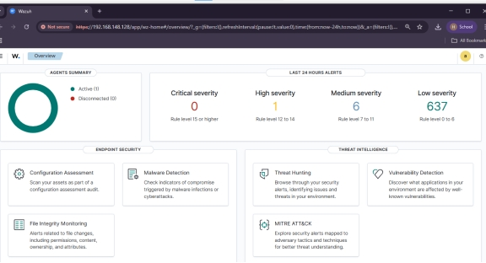
- Deployed Wazuh All-in-One installation
- Components installed:
  - Manager
  - Dashboard
  - Indexer
- Dashboard verified via browser access
Outcome:
✔ Wazuh services running successfully

3.2 Wazuh Agent Installation & Registration
- Installed Wazuh Agent on Windows 10
- Configured agent to connect to:
  - 127.0.0.1
- Agent registered using:
  - manage_agents.exe
- Agent status verified on dashboard
Outcome:
✔ Logs successfully forwarded to manager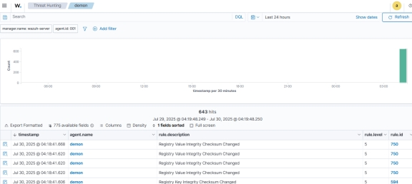

COMMANDS USED
Wazuh Manager Installation (Ubuntu Linux)
Step 1: Update System Packages
sudo apt update && sudo apt upgrade -y

Step 2: Download and Run Wazuh All-in-One Installation Script
curl -sO https://packages.wazuh.com/4.7/wazuh-install.sh
sudo bash wazuh-install.sh -a
➡ This installs:
- Wazuh Manager
- Wazuh Indexer
- Wazuh Dashboard

Step 3: Verify Wazuh Services
sudo systemctl status wazuh-manager
sudo systemctl status wazuh-indexer
sudo systemctl status wazuh-dashboard

Step 4: Access Wazuh Dashboard
https://<manager-ip>
(Default port: 5601)

2. Wazuh Agent Deployment on Windows 10

Step 1: Download Wazuh Agent (Windows)
Downloaded from official site:
https://packages.wazuh.com/4.x/windows/wazuh-agent.msi

Step 2: Install Wazuh Agent (GUI or Silent Mode)
Silent Installation Command
msiexec /i wazuh-agent.msi /qn WAZUH_MANAGER="192.168.1.100"
(Replace IP with Wazuh Manager IP)

Step 3: Register Agent with Manager
Open Command Prompt as Administrator:
"C:\Program Files (x86)\ossec-agent\manage_agents.exe"
Choose:
- A → Add agent
- Enter agent name
- Enter manager IP

Step 4: Start Wazuh Agent Service
net start WazuhSvc
OR
sc start WazuhSvc

Step 5: Verify Agent Status on Manager
sudo /var/ossec/bin/agent_control -l
Agent should appear as Active

3. Enable Log Collection on Windows (Optional but Used)
Edit:
C:\Program Files (x86)\ossec-agent\ossec.conf
Enable Windows Event Logs:
<localfile>
<location>Security</location>
<log_format>eventchannel</log_format>
</localfile>

Restart agent:
net stop WazuhSvc
net start WazuhSvc

4. Confirmation
- Agent appears on Wazuh Dashboard
- Logs successfully ingested
- Real-time monitoring active

4. IDS Integration: Suricata with Wazuh
4.1 Objective
To enhance network-level threat detection by integrating Suricata IDS with Wazuh.
4.2 Implementation Summary
- Integrated Suricata with Wazuh for real-time IDS alerts
- Created a custom ICMP detection rule
- Configured Wazuh to decode Suricata’s JSON alerts
4.3 Custom Suricata Rule
alert icmp any any -> any any (msg:"ICMP Ping Detected - Custom Test"; sid:1000001; rev:1;)
4.4 Log Forwarding Configuration
Suricata logs forwarded from:
/var/log/suricata/eve.json
4.5 Result
ICMP ping alerts successfully appeared in Wazuh Security Events dashboard
IDS alerts centralized with host logs

INTEGRATION OF SURICATA
Integrated Suricata with Wazuh for real-time IDS/alerting! Created a custom Suricata rule to detect ICMP pings and configured the Wazuh manager to decode and surface events in the Security Events dashboard. Result: alerts from Suricata now appear in Wazuh with actionable context.
Use this one-liner to demonstrate a live test:
1) Add rule:
sudo nano /etc/suricata/rules/local.rules
alert icmp any any -> any any (msg:"ICMP Ping Detected - Custom Test"; sid:1000001; rev:1;)
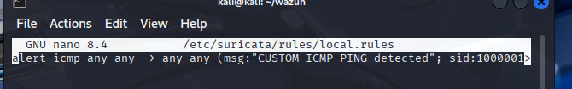
2) Reload Suricata and generate traffic:
sudo systemctl restart suricata
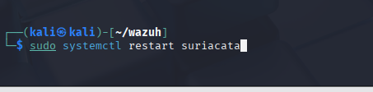
ping -c 4 <target-ip>
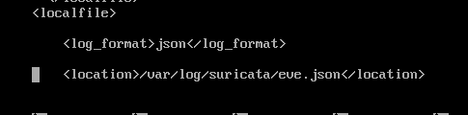
What I did:
• Added a custom Suricata rule to detect ICMP pings.
• Configured the Wazuh agent to forward Suricata's eve.json (JSON) logs.
• Created a lightweight decoder and a Wazuh rule on the manager so Suricata's JSON alerts are decoded and converted into Wazuh alerts.
Why this matters:
• Centralized visibility — IDS alerts are searchable alongside other telemetry in Wazuh.
• Actionable context — Wazuh enriches alerts and makes them easier to triage.
Commands & snippets used:
Suricata rule (add to /etc/suricata/rules/local.rules):
alert icmp any any -> any any (msg:"ICMP Ping Detected - Custom Test"; sid:1000001; rev:1;)
Wazuh agent (on the monitored host) - forward JSON logs:
<localfile>
<log_format>json</log_format>
<location>/var/log/suricata/eve.json</location>
</localfile>
Wazuh manager - decoder (place under /var/ossec/etc/decoders/):
<decoder_list>
<decoder name="suricata">
<prematch>suricata</prematch>
</decoder>
</decoder_list>
Testing:
• Run a ping (from another host or the same host depending on interface): ping -c 4 <your_suricata_ip>
• On the manager, tail alerts: sudo tail -f /var/ossec/logs/alerts/alerts.json

5.Implementation of Security Pillars (NIST Controls)
The following five pillars were implemented to achieve a defensible security posture:

Pillar 1: Vulnerability Detection (Control RA-5)
- Objective: Identify unpatched software and operating system vulnerabilities.
- Implementation: Enabled the <vulnerability-detector> module on the Wazuh Manager to download daily CVE feeds from Canonical and Microsoft.
- Configuration: Configured the syscollector module on the agent to report full software inventory every hour.
- Result: Successfully identified critical vulnerabilities (CVE-2025-XXXX) on the target endpoint.
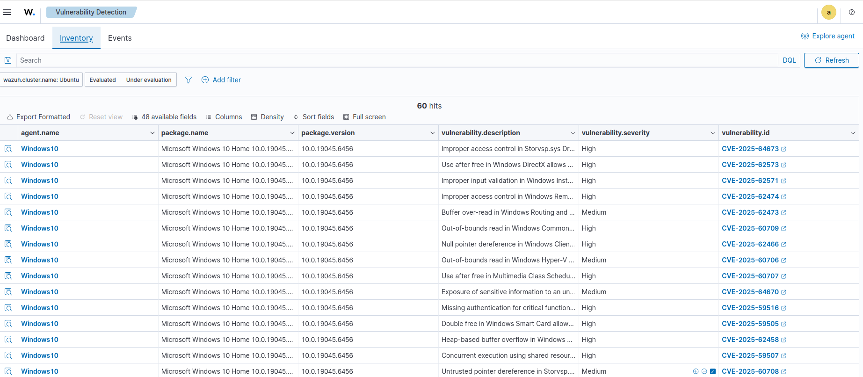

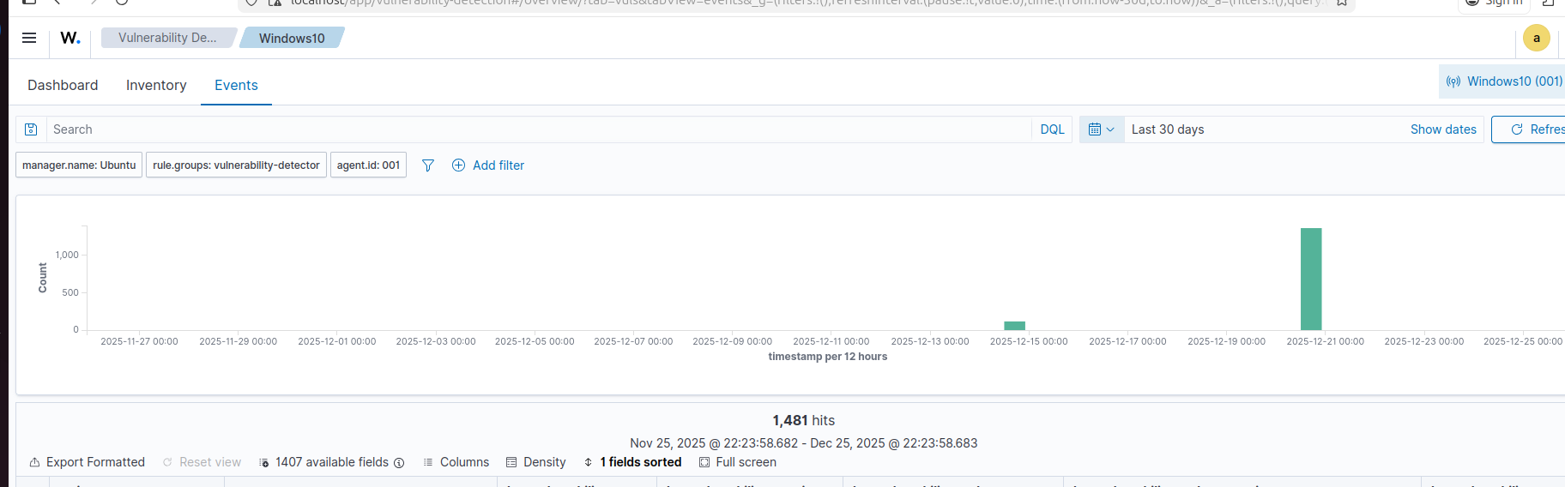

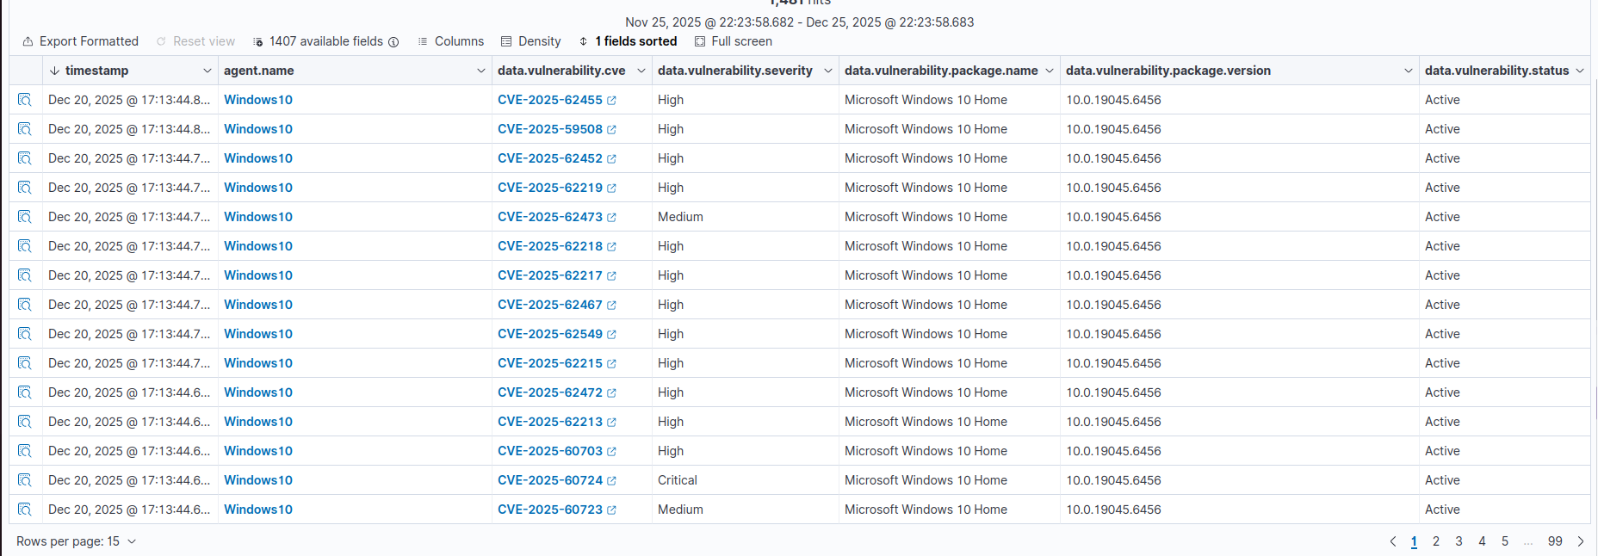

Pillar 2: File Integrity Monitoring (Control SI-7)
Setup
- - Enabled FIM to monitor C:\Users\Public.
- Edited configuration in ossec.conf:
<syscheck>
<directories check_all="yes">C:\Users\Public</directories>
<frequency>10</frequency>
</syscheck>

- 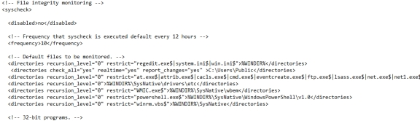
- Restarted Wazuh agent.
Outcome: Agent monitoring started successfully.

- Objective: Detect unauthorized modification of sensitive files.
- Implementation: Configured the Wazuh syscheck module to monitor specific directories in real-time.
- Custom Rule: Added a dedicated watch path to bypass Windows system protections for testing:
XML
<directories check_all="yes" realtime="yes" report_changes="yes">C:\nist_test_folder</directories>

- Result: System generated instant alerts for file creation, modification, and deletion events.
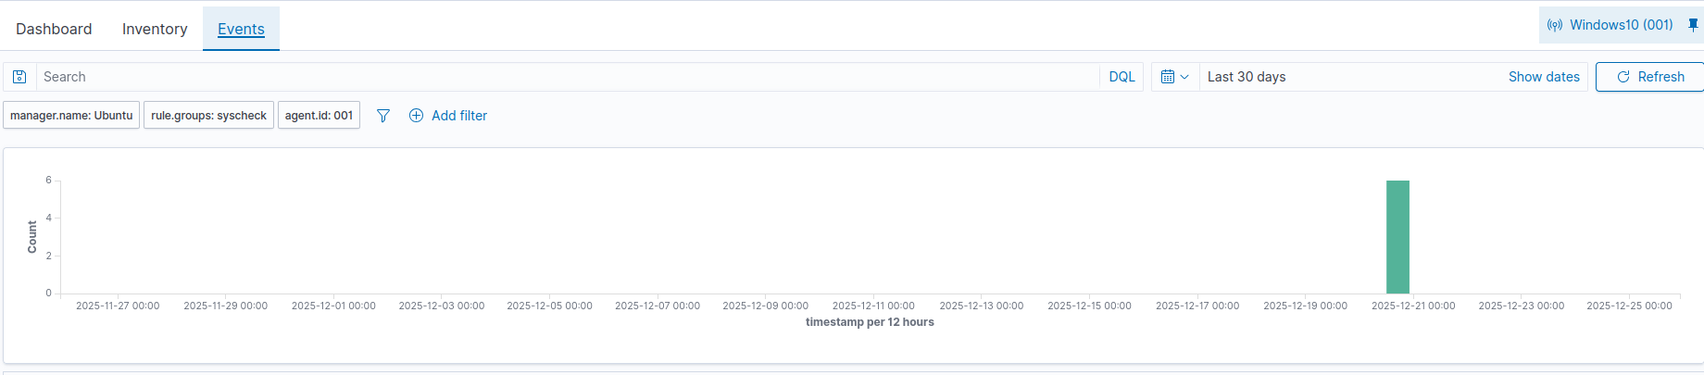

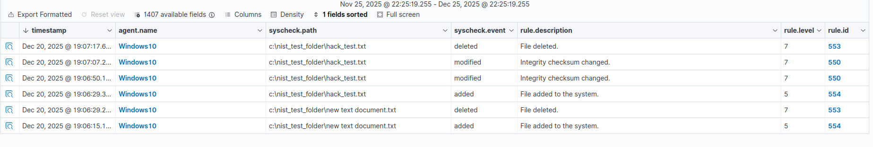

Pillar 3: Section 3. Implementation of NIST Control CM-6)
3.1 Objective The goal of this control is to establish and maintain a secure baseline configuration for the information system. We achieved this by deploying specific configuration policies that monitor the system for deviations from secure standards (hardening).

3.2 Methodology: Custom Policy Deployment To satisfy the CM-6 requirements, we utilized the Wazuh Security Configuration Assessment (SCA) module with a custom policy set. We chose not to rely solely on default policies but instead integrated updated rules to ensure maximum coverage.

3.3 Execution Steps

Policy Sourcing: We retrieved the latest SCA policy definitions from an external repository (Git). This ensures the system is checked against the most current security benchmarks and vulnerability definitions.

Integration: The downloaded policy files (.yml format) were manually deployed to the target machine's SCA configuration directory:

Directory Path: /var/ossec/etc/sca

Action: Overwrote/Added policies to define the "Least Privilege" settings required by NIST.

Enforcement: The Wazuh agent service was restarted to apply the changes:

Command: systemctl restart wazuh-agent

This action triggered an immediate re-scan of the system's configuration. The agent parsed the new files and mapped the checks to NIST 800-53 references embedded within the YAML files.

3.X.4 Result The system immediately began reporting compliance pass/fail rates based on the new files. This provides the Information Assurance team with a real-time view of any misconfigurations (e.g., open ports, weak passwords, unencrypted protocols) that violate NIST CM-6.

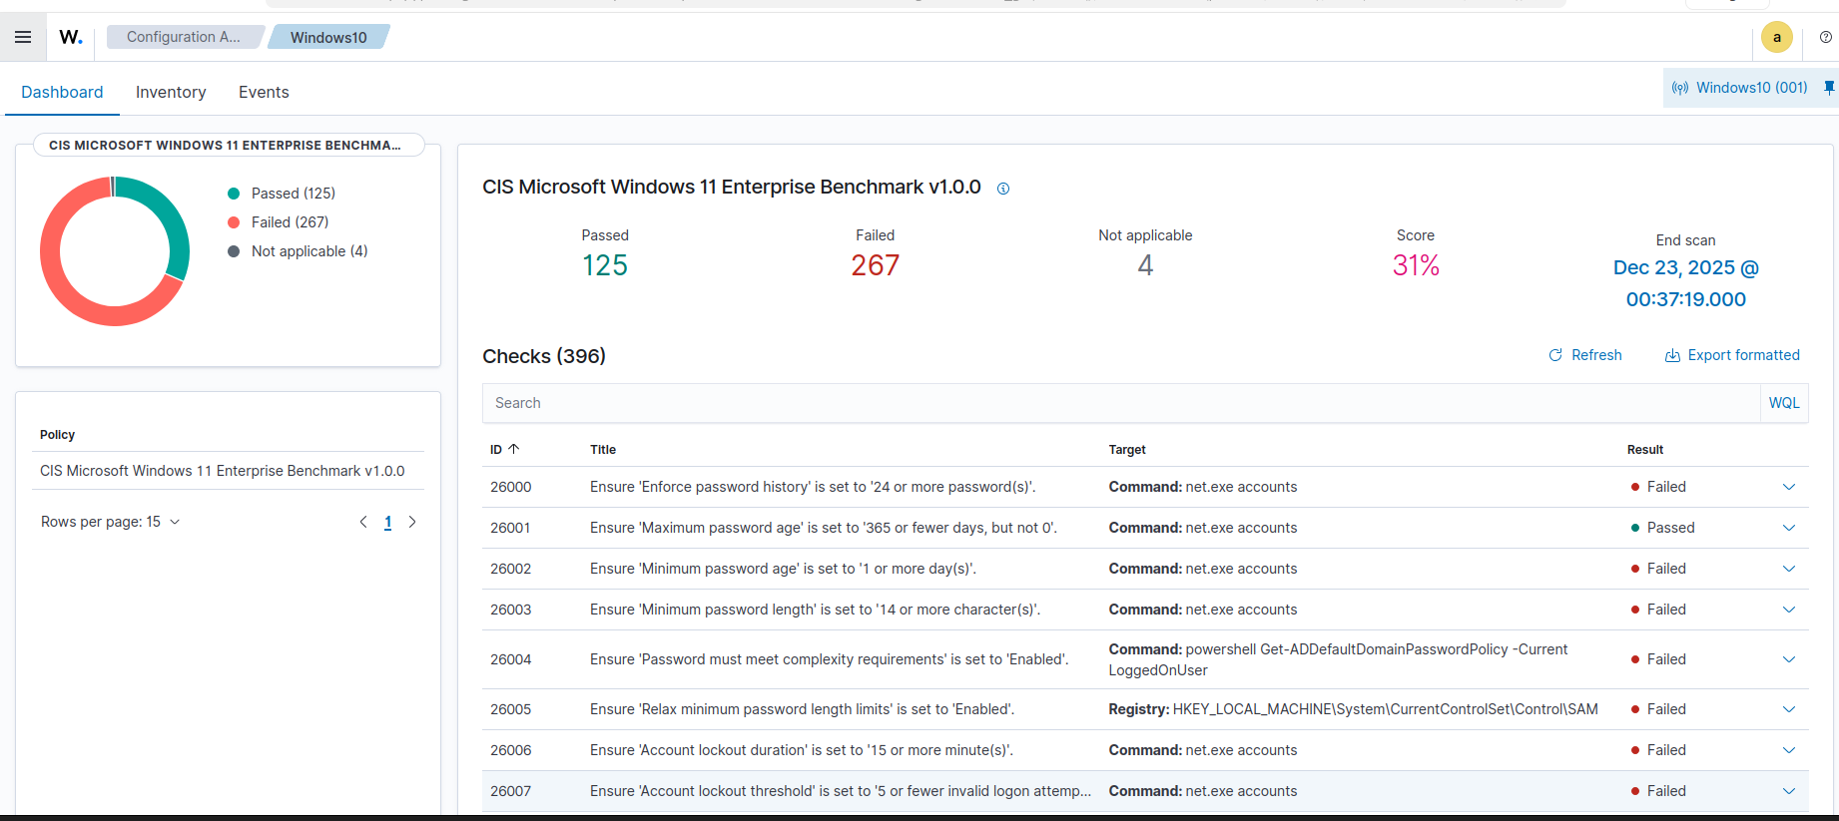

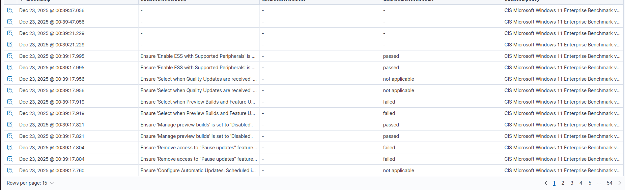

Pillar 4: Access Control Monitoring (Control AC-2 / AC-7)
- Objective: Monitor for unauthorized access and account manipulation.
- Implementation: Ingested Windows Event Logs (Security Channel) into the SIEM.
- Result: Detected simulated brute force attacks (failed logins) and unauthorized privilege escalation (adding users to Administrator groups).
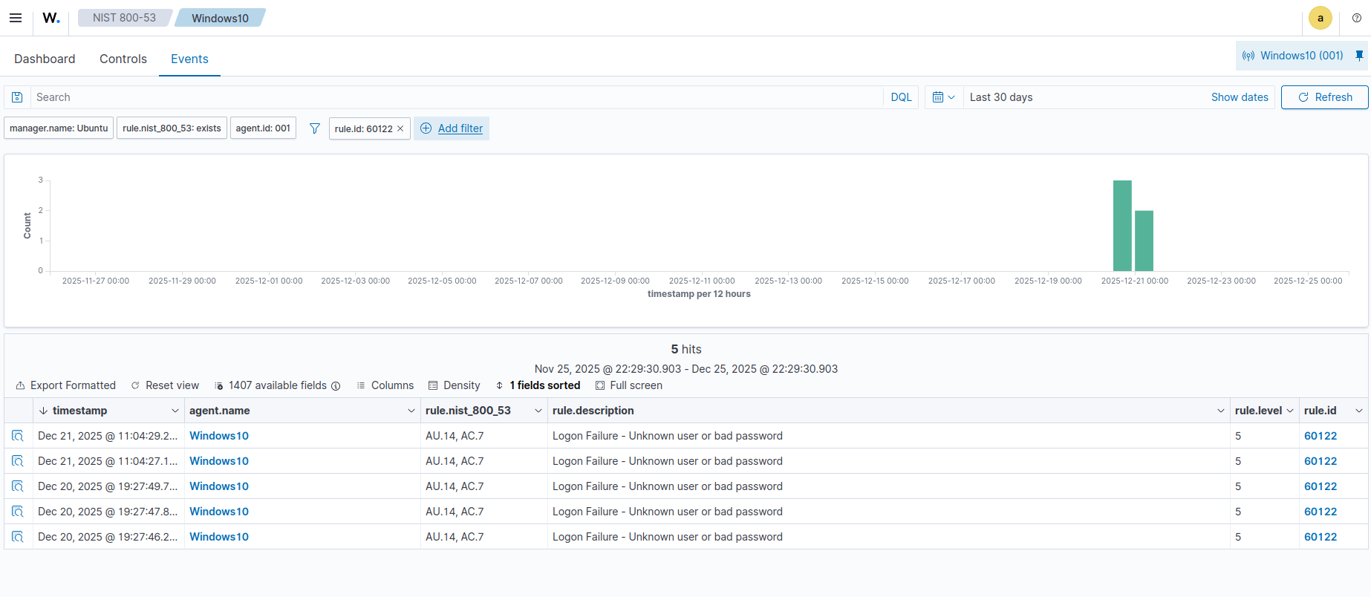

Pillar 5: Audit & Log Retention (Control AU-6)
- Objective: Centralize logs to prevent tampering.
- Implementation: Configured secure, encrypted log forwarding from Agent to Manager on port 1514.
- Result: Verified archival of all security events on the Ubuntu Manager (/var/ossec/logs/archives).

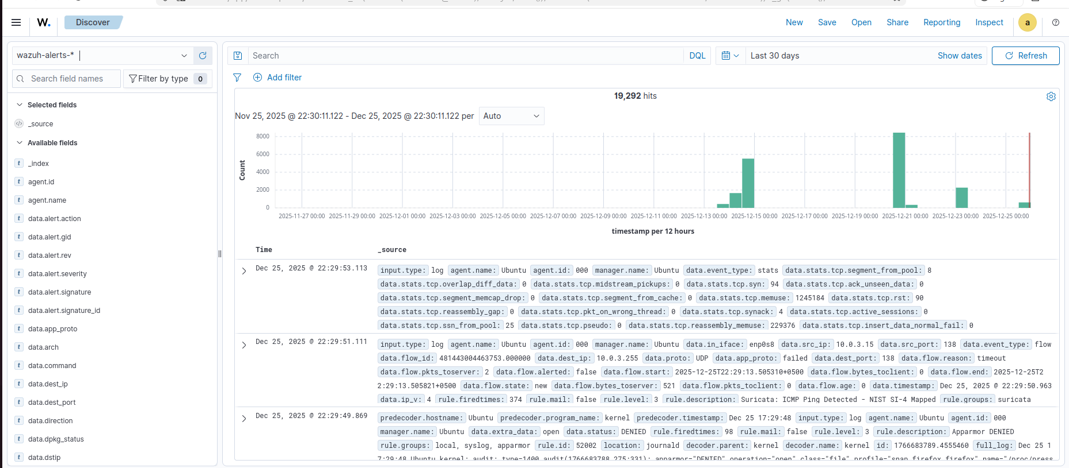

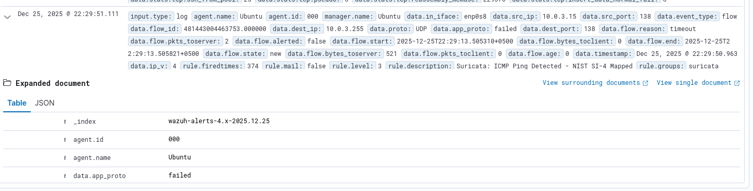

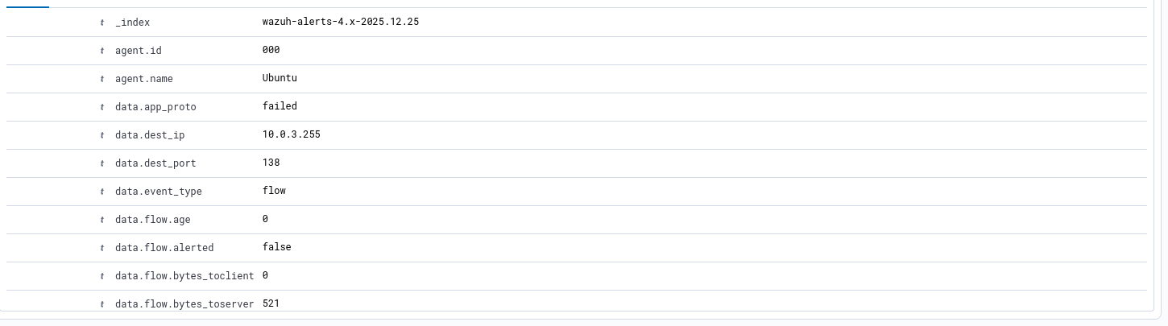

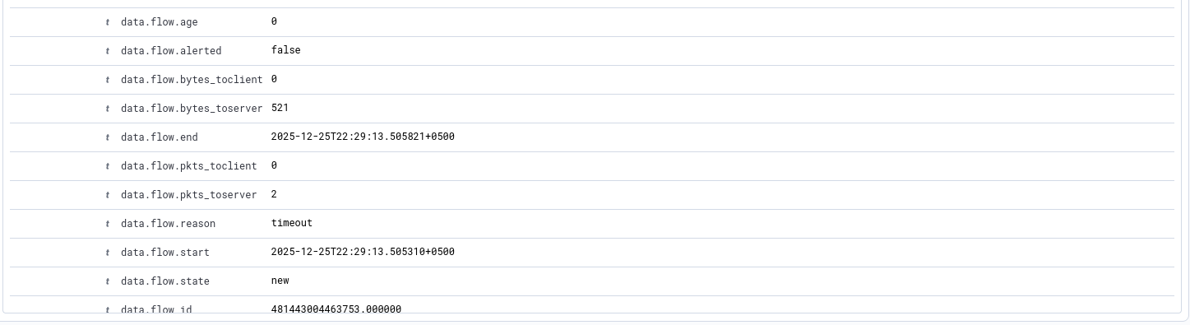

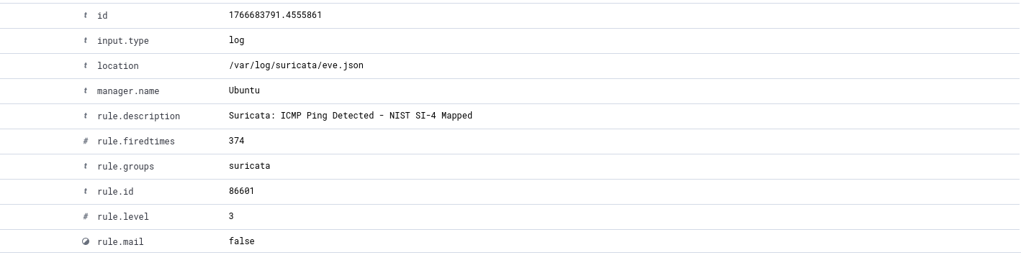

6. Threat Simulation & Validation
To validate the efficacy of the controls, the following adversarial techniques were simulated:
Attack Type | Command Executed | Detection Result | NIST Mapping
File Tampering | New-Item -Path "C:\nist_test_folder\malware.txt" | Detected: "File added to system" | SI-7
Persistence | net localgroup administrators hacker /add | Detected: "User added to local group" | AC-2
Service Modification | net start Spooler | Detected: "Service state changed" | CM-3

